Table 4. SW, KG and MER values for multiple experiments
 | S.no | pressure (MPa) | stand of distance (mm) | traverse speed (mm/min) | Mass flow rate (kg/min) | Surface Waviness  (µm) | Material Erosion Rate | Kerf Gap  (mm)
 | 1 | 220 | 2 | 80 | 0.4 | 4.75 | 119.98 | 2.08
 | 2 | 260 | 1 | 64 | 0.55 | 3.09 | 126.36 | 1.44
 | 3 | 220 | 2 | 80 | 0.45 | 4.46 | 122.4 | 1.98
 | 4 | 140 | 3 | 96 | 0.55 | 5.02 | 111.57 | 2.25
 | 5 | 300 | 1 | 96 | 0.35 | 3.84 | 126.63 | 1.75
 | 6 | 140 | 1 | 64 | 0.35 | 5.04 | 97.63 | 2.25
 | 7 | 220 | 2 | 72 | 0.45 | 4.38 | 121.6 | 1.95
 | 8 | 140 | 3 | 64 | 0.55 | 4.61 | 109.81 | 2.09
 | 9 | 280 | 2 | 80 | 0.45 | 4.14 | 137.08 | 1.83
 | 10 | 300 | 1 | 64 | 0.35 | 3.5 | 117.28 | 1.59
 | 11 | 300 | 3 | 96 | 0.35 | 3.97 | 143.3 | 1.86
 | 12 | 220 | 2 | 88 | 0.45 | 4.63 | 125.7 | 2.04
 | 13 | 140 | 3 | 96 | 0.35 | 5.56 | 106.95 | 2.57
 | 14 | 300 | 3 | 96 | 0.55 | 3.62 | 148.41 | 1.64
 | 15 | 140 | 1 | 64 | 0.55 | 4.08 | 102.02 | 1.86
 | 16 | 180 | 2 | 80 | 0.45 | 4.75 | 115.2 | 2.15
 | 17 | 220 | 2 | 80 | 0.45 | 4.46 | 122.4 | 1.98
 | 18 | 220 | 1.5 | 80 | 0.45 | 4.41 | 119.69 | 1.96
 | 19 | 300 | 3 | 64 | 0.55 | 3.42 | 145.92 | 1.52
 | 20 | 220 | 2 | 80 | 0.5 | 4.27 | 131.74 | 1.93
 | 21 | 220 | 2.5 | 80 | 0.45 | 4.67 | 132.71 | 2.05
 | 22 | 140 | 1 | 96 | 0.35 | 5.36 | 99.7 | 2.43
 | 23 | 300 | 1 | 96 | 0.55 | 3.29 | 140.98 | 1.48
 | 24 | 220 | 2 | 80 | 0.45 | 4.46 | 122.4 | 1.98
 | 25 | 140 | 1 | 96 | 0.55 | 4.53 | 104.26 | 2.08
 | 26 | 140 | 3 | 64 | 0.35 | 5.23 | 103.66 | 2.34
 | 27 | 300 | 3 | 64 | 0.35 | 3.80 | 139.85 | 1.73

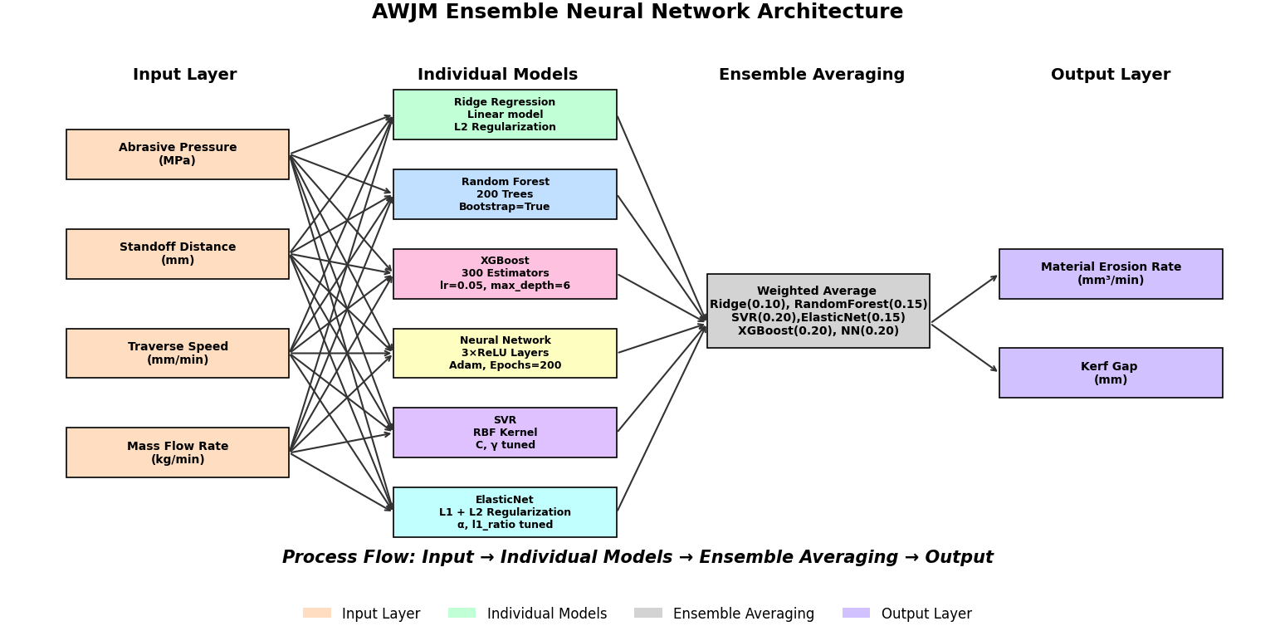

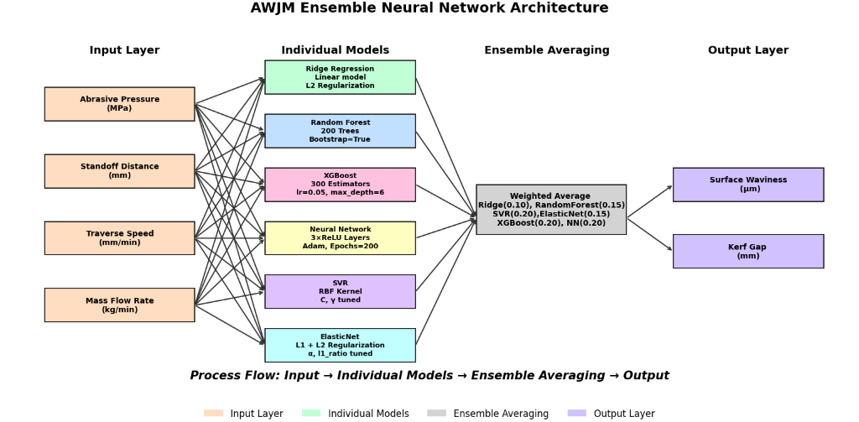

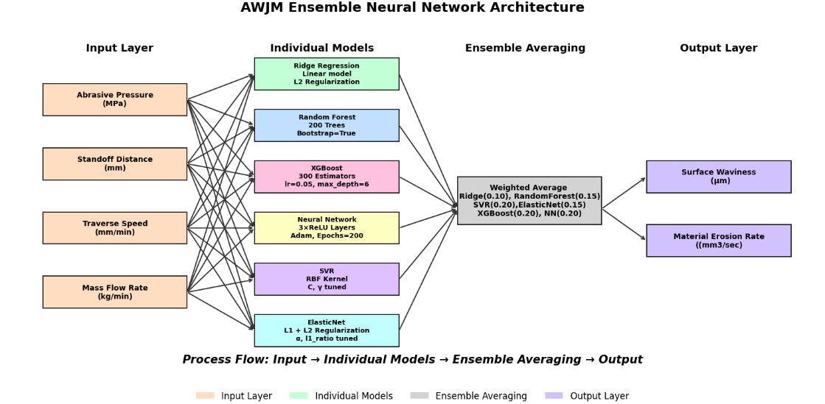

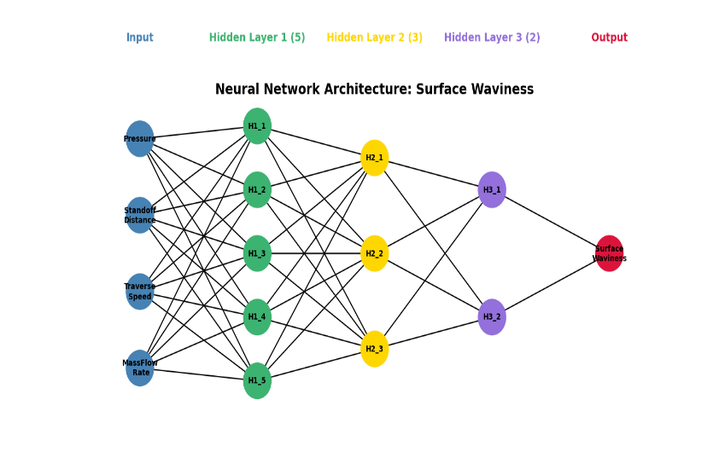
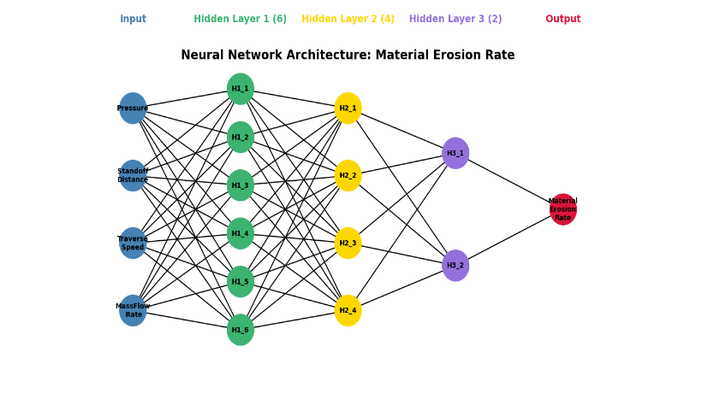

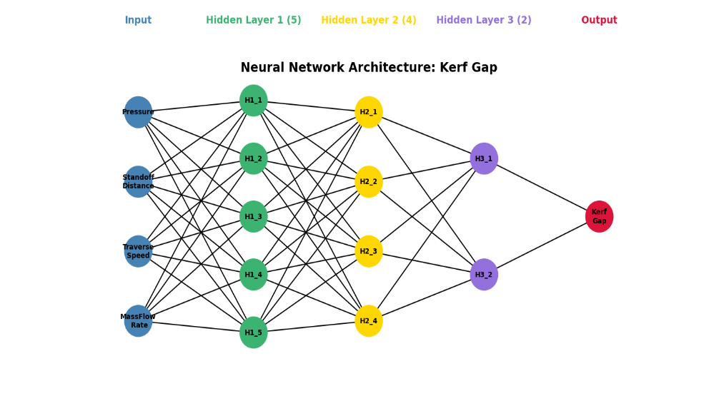

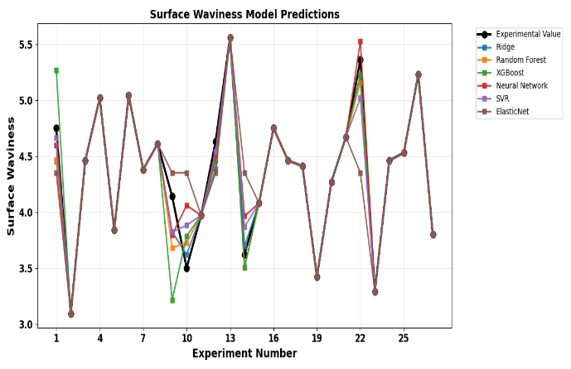
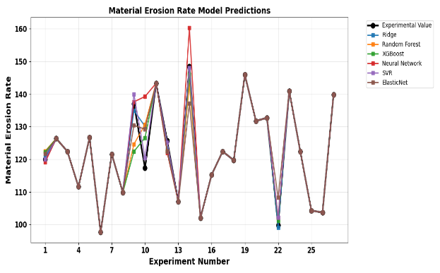

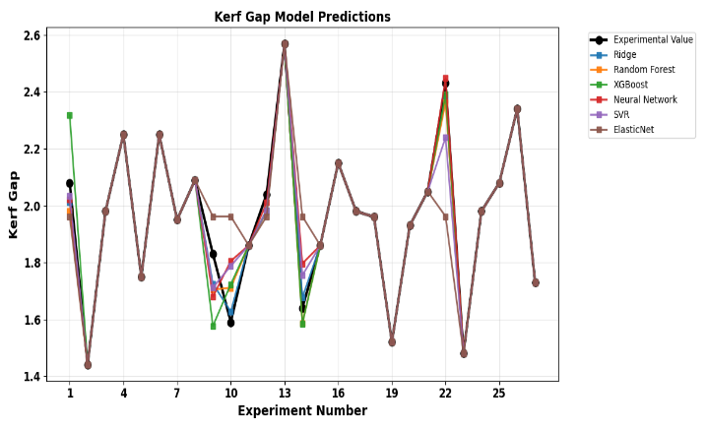

Fig. 7. Validation of each model with experimental value

Table 6: Ensemble Model performance.
Ensemble Model Performance Summary
Target | RMSE | MAE | R²
Surface Waviness | 0.0790 | 0.0663 | 0.9839
Material Erosion Rate | 1.8730 | 1.5581 | 0.9831
Kerf Gap | 0.0448 | 0.0396 | 0.9739

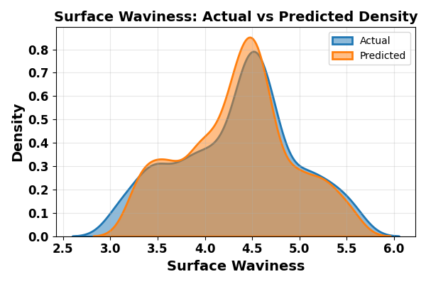
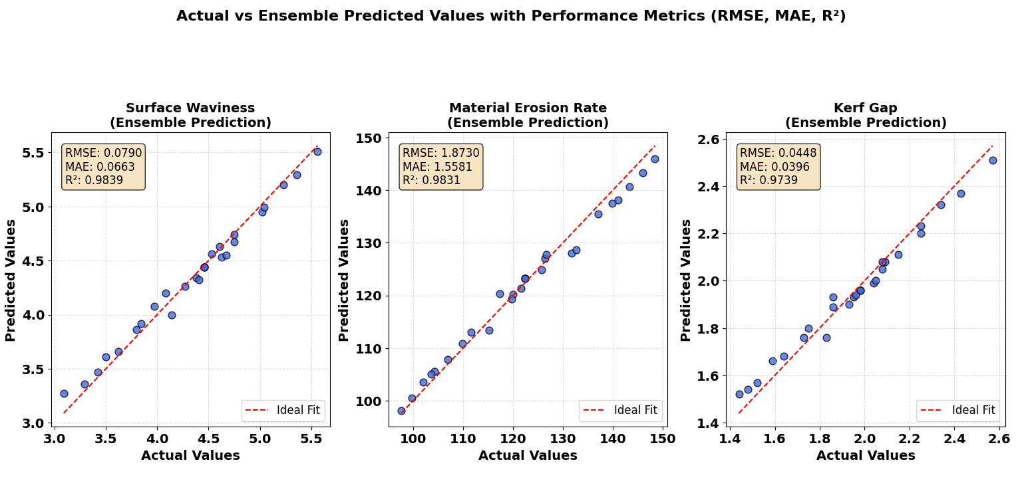
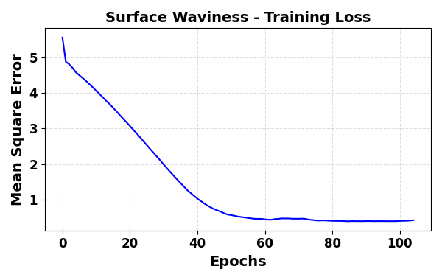

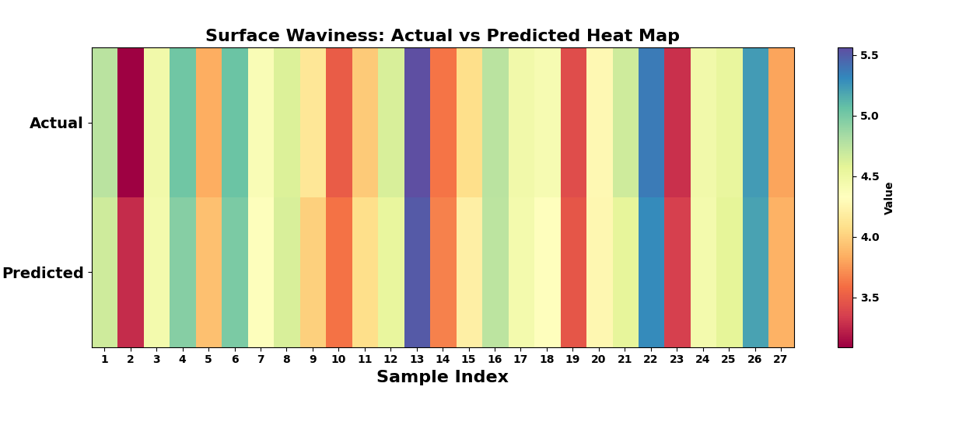
(a) (b) (c)

Fig. 8. Ensemble Surface Waviness Model Performance (a) Training and Validation Curve (b) Actual vs Predicted value (c) Density curve (d) Heat map.

(d)
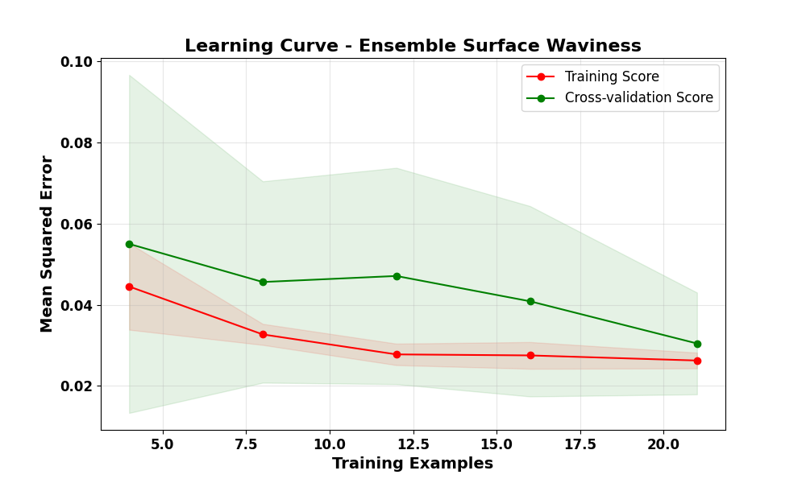

Fig. 11. Learning curve for Cross-validation Surface Waviness

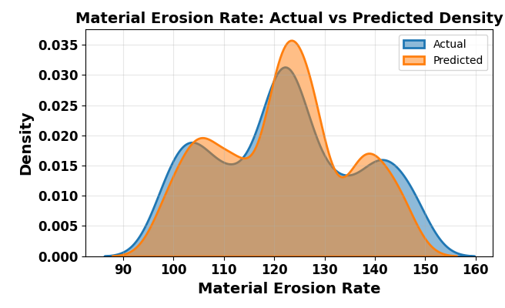

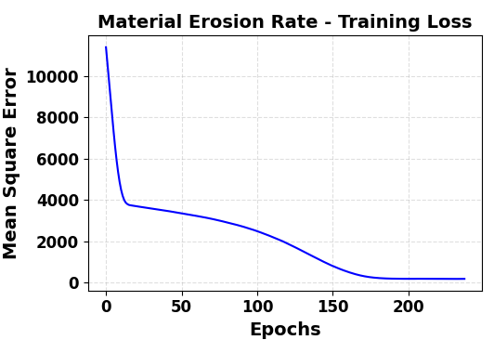
Material Erosion Rate

(a) (b) (c)
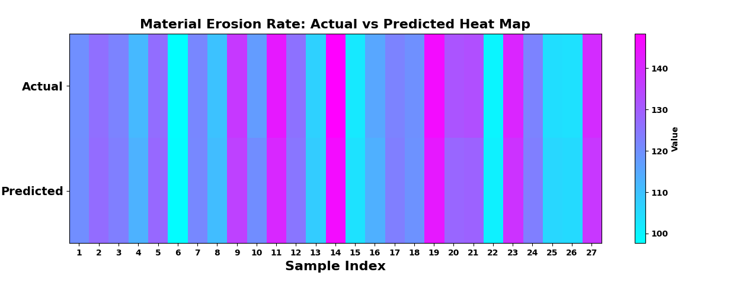

Fig. 8. Ensemble Material Removal Rate Model Performance (a) Training and Validation Curve (b) Actual vs Predicted value (c) Density curve (d) Heat map.

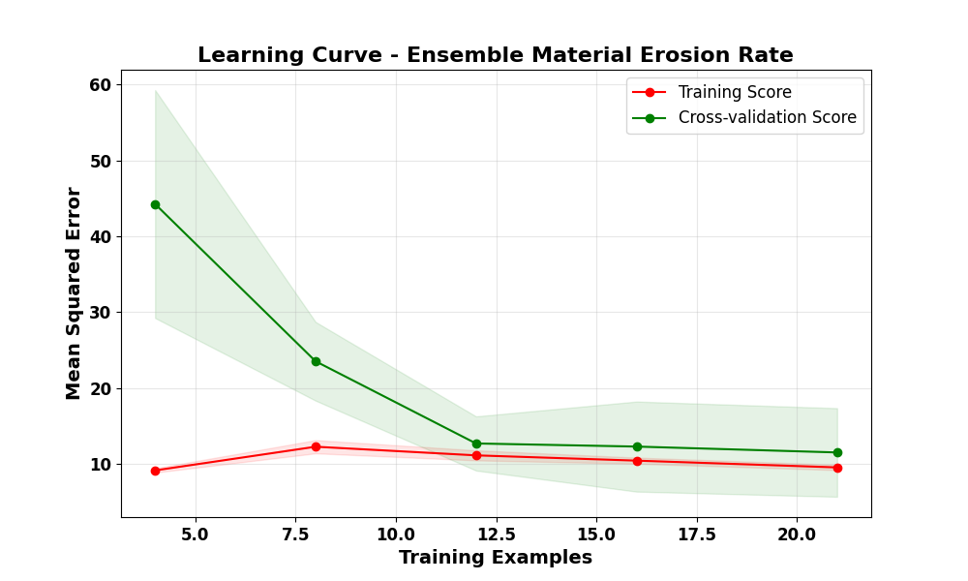
(d)

Fig. 11. Learning curve for Cross-validation Material Erosion Rate

KERF GAP

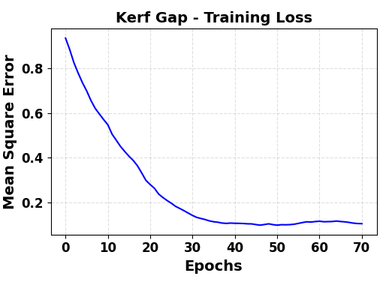
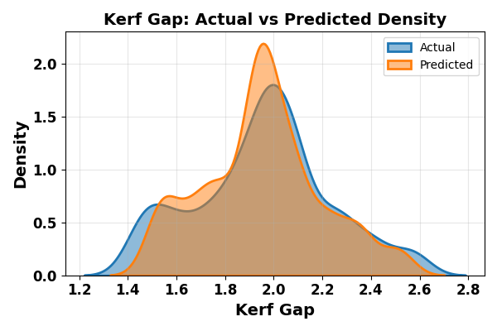

- (b) (c)
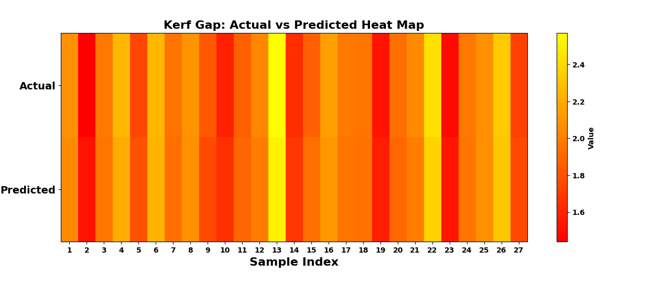

Fig. 8. Ensemble Kerf Gap Performance (a) Training and Validation Curve (b) Actual vs Predicted value (c) Density curve (d) Heat map.

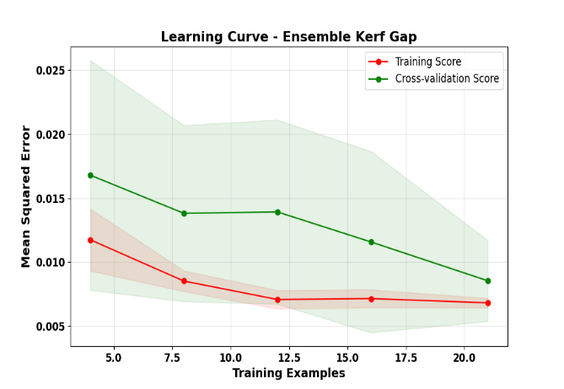
(d)

Fig. 11. Learning curve for Cross-validation Kerf Gap

Table 3: Optimal Process Parameter Settings for Different Objectives
Parameter | Min SW | Max MER | Balanced
Pressure (MPa) | 260.00 | 300.00 | 300.00
Standoff Distance (mm) | 1.00 | 3.00 | 3.00
Traverse Speed (mm/min) | 64.00 | 96.00 | 96.00
Mass Flow Rate (kg/min) | 0.55 | 0.55 | 0.55
Expected SW(μm) | 3.27 | 3.66 | 3.66
Expected MER (mm³/min) | 126.98 | 148.59 | 148.59
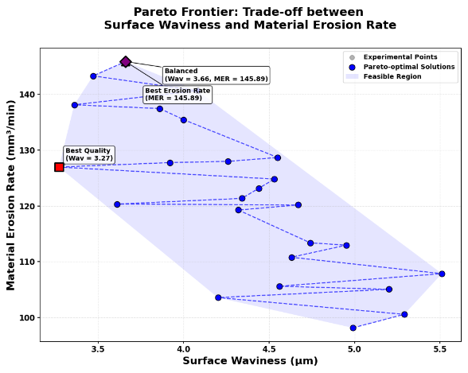

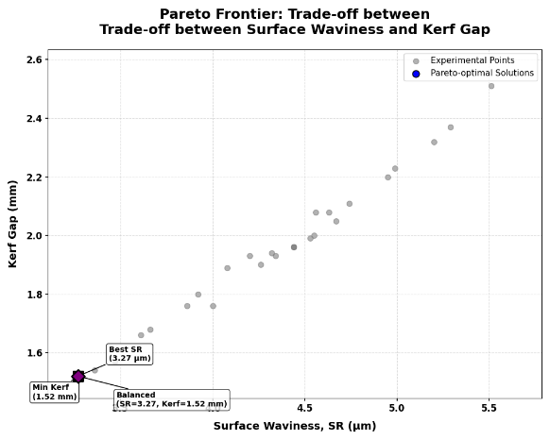
Table 3: Optimal Process Parameter Settings for Different Objectives
Parameter | Min SW | Min Kerf | Balanced
Pressure (MPa) | 260.00 | 260.00 | 260.00
Standoff Distance (mm) | 1.00 | 1.00 | 1.00
Traverse Speed (mm/min) | 64.00 | 64.00 | 64.00
Mass Flow Rate (kg/min) | 0.55 | 0.55 | 0.55
Expected SW (μm) | 3.27 | 3.27 | 3.27
Expected kerf (mm) | 1.52 | 1.52 | 1.52

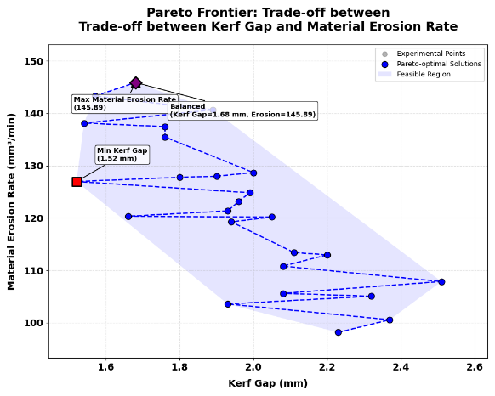
Table 3: Optimal Process Parameter Settings for Different Objectives
Parameter | Min Kerf | Max MER | Balanced
Pressure (MPa) | 260.00 | 300.00 | 300.00
Standoff Distance (mm) | 1.00 | 3.00 | 3.00
Traverse Speed (mm/min) | 64.00 | 96.00 | 96.00
Mass Flow Rate (kg/min) | 0.55 | 0.55 | 0.55
Expected Kerf (mm) | 1.52 | 1.68 | 1.68
Expected MER (mm³/min) | 126.98 | 145.89 | 145.89

Table 3: Optimal Process Parameter Settings for Different Objectives

BOOSTRAP
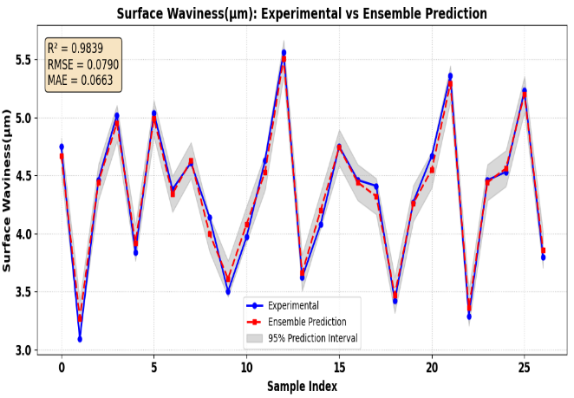
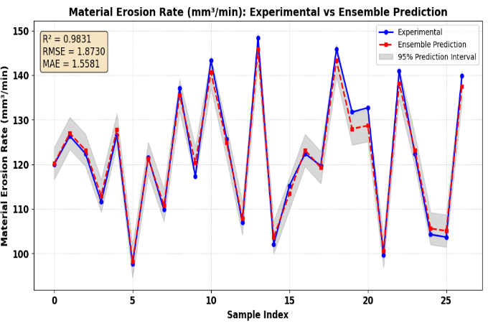

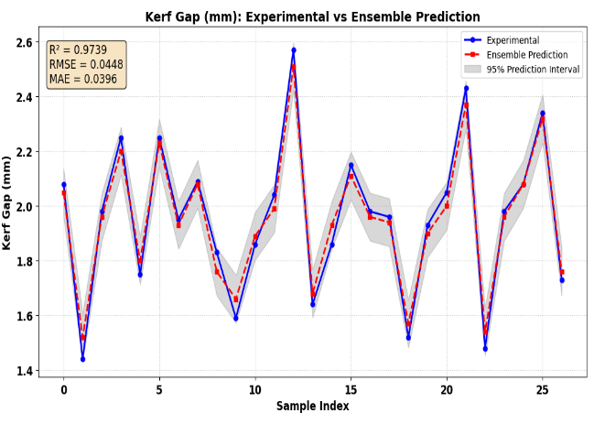

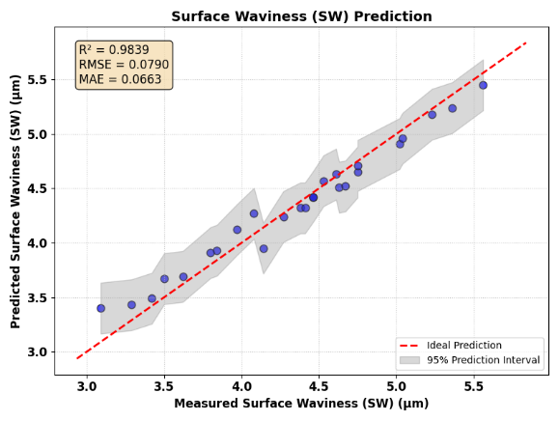
HYBRID Ensemble
